**Aim: Creation of Cursor**

Outcome: PL/SQL block using Cursor

1.Use Emp (system table) for following:

1. Display id and name of employee who are working as Salesman. (using %Type)

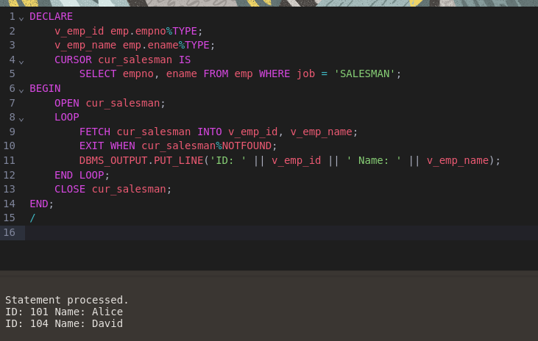

1. Display all the information of employee belong to dept no 10 (using %RowType)

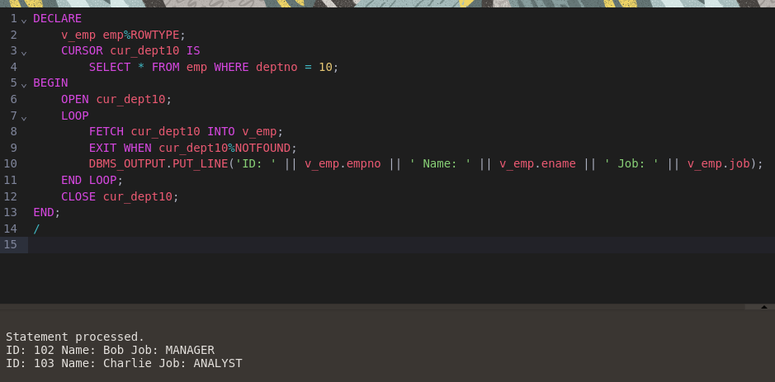

1. Display name,dept no,salary of first highest paid employee

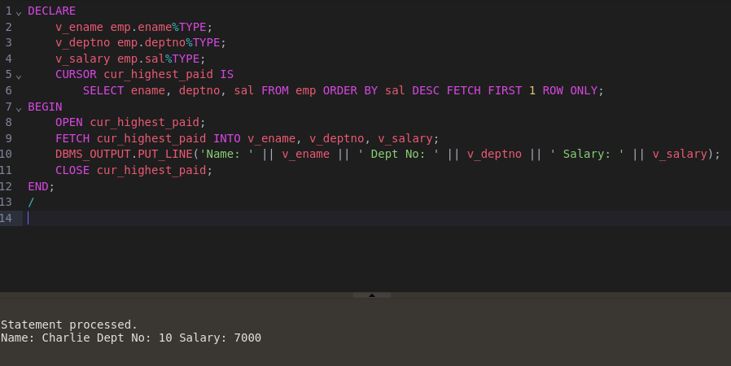

1. Display the employee details along with salary (Between range : A to B)

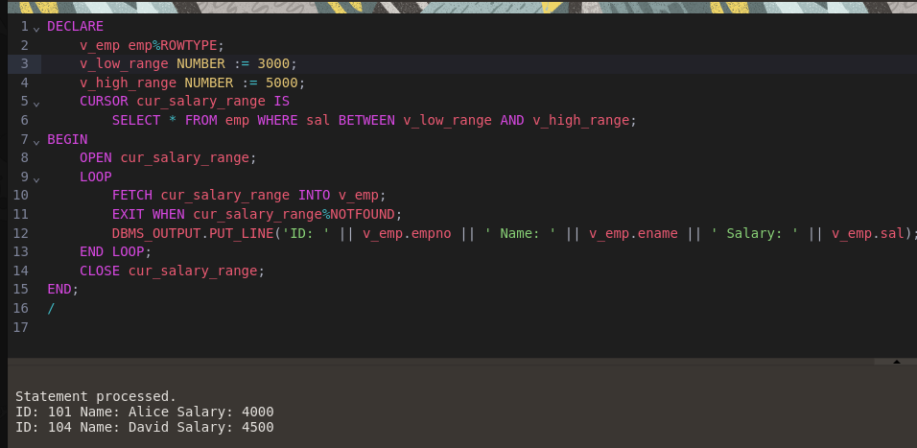

1. Display the employee working as a Manager or Analyst.

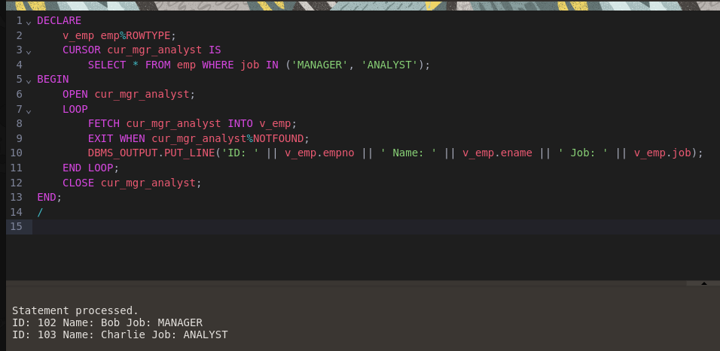

2.Employee (id,name,TA , DA, HRA,Gross,Bonus)

Calculate Gross salary and bonus (10% of salary) and insert into table (%Type OR %RowType)

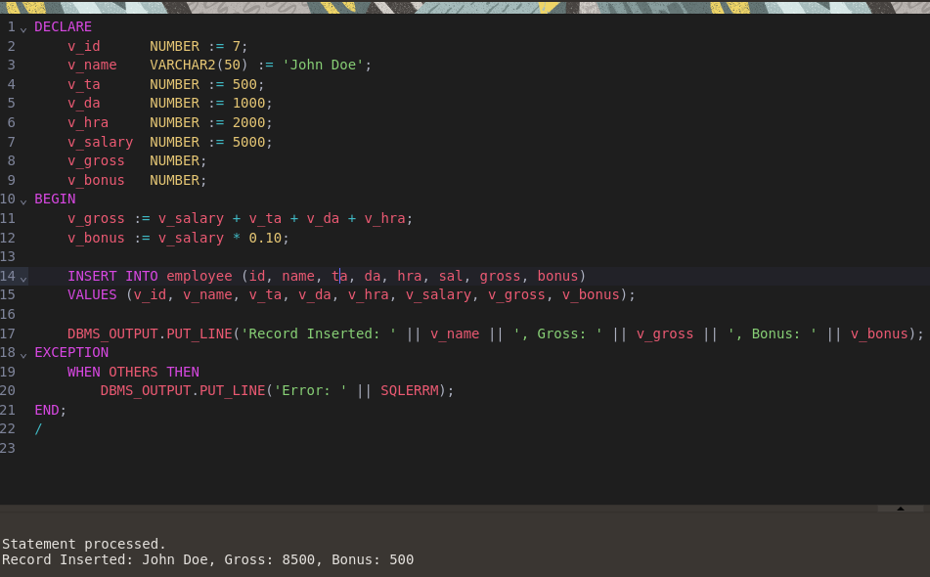

3. Write an anonymous PL/SQL block that…

* + Defines a cursor that points to a record set that contains the sailors’ names, reservation date and boat id where the boat color is red
  + Opens the cursor
  + Uses a simple loop to fetch each record in the active set
  + Displays each last name, reservation date and boat id for each record to the output screen
  + **Schema**

Sailor (sid, sname, rating, age)

Boat (bid, bname, color)

Reservation(sid, bid, day)

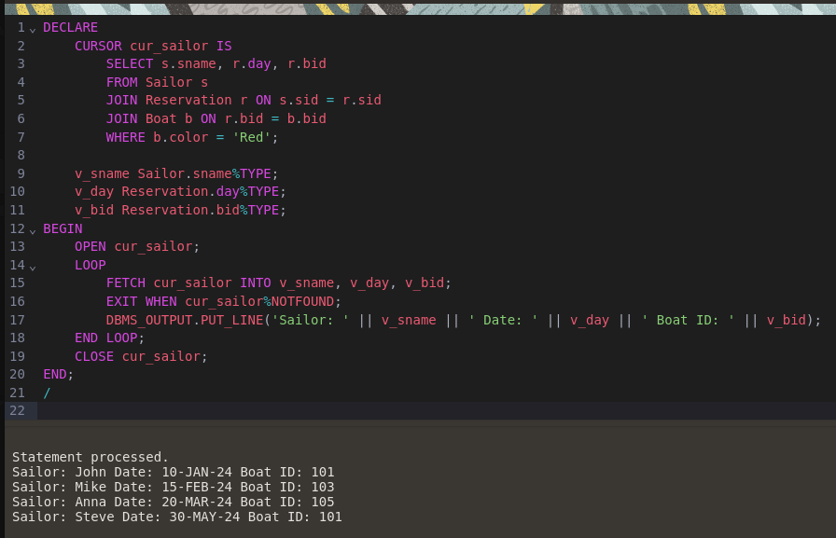

4. Try following attributes for SQL implicit Cursor:

* SQL%FOUND

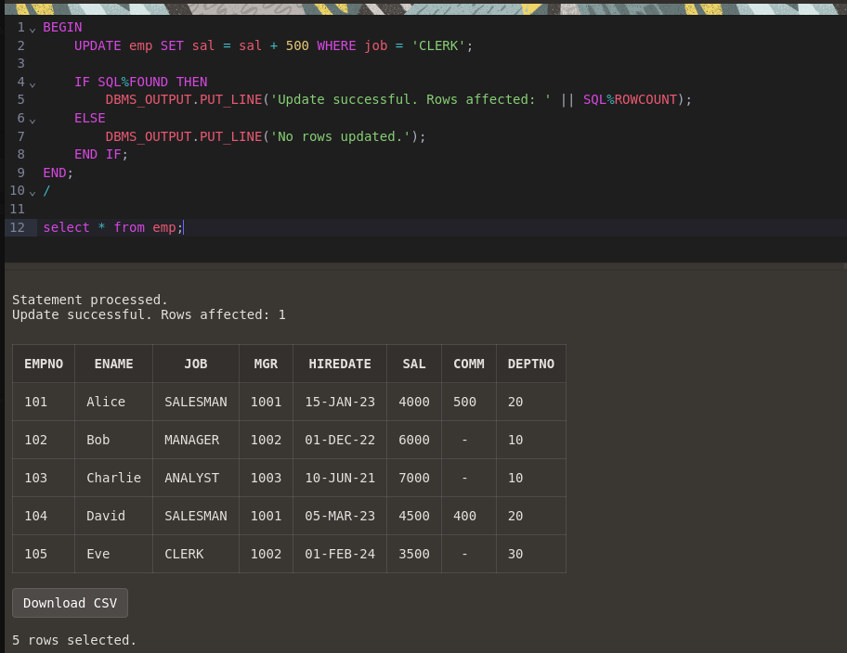

* SQL%NOTFOUND’

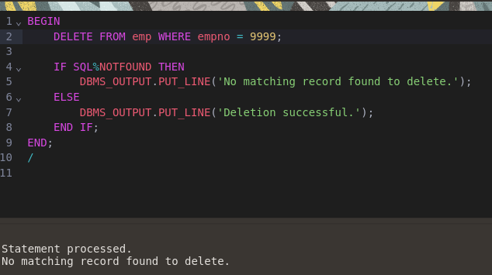

* SQL%ROWCOUNT

